Pentapod

Jochen Alt



Leg Design

Typical Hexapods have 3-5 DOF per leg, most of them have only one DOF that move the from left to right and all other DOFs to move it up and down. I never go the reason behind, since when looking at most of the hexapods you get the impression of a “brutal” gait since the entire leg including the thigh (or “femur”) is moving while *not* trying to minimize the mass that is to be accelerated. There’s just one hexapod I am aware of (“Weaver”) that spends one DOF for turning a leg such that the foot can move forward and backward without moving the femur. Unfortunately, this DOF is not used during walking but only to compensate standing on a ramp and levelling the body’s orientation.

In order to minimize the moved mass, it seems natural to turn the knee, what led to a 4 DOF leg design with a turning possibility at the knee:

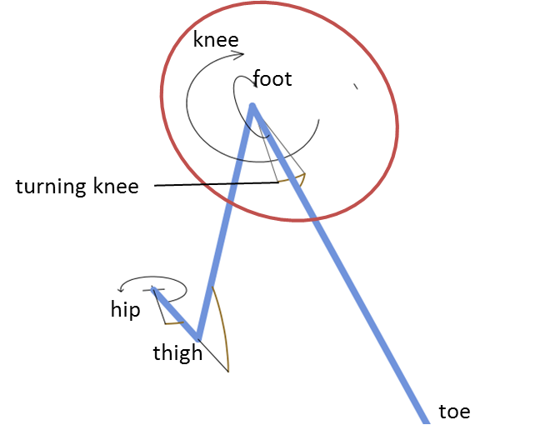The blue lines illustrate the leg consisting of the joints hip, thigh, knee and foot.

The turning knee (later on **) allows to move the toe to the left and the right without moving the tibia. This should allow more efficient movements since the tibia moves less compared to a classical design without a turning knee.

In this chapter, we assume the coordinate system in the hip. The axis’s directions is shown in the next picture.

Kinematics

Kinematics is about computation of the toe’s point out of the joint angles and vice versa. First is simple, latter is tricky. The coordinate systems are illustrated as follows, such that we can derive the Denavit Hardenberg.

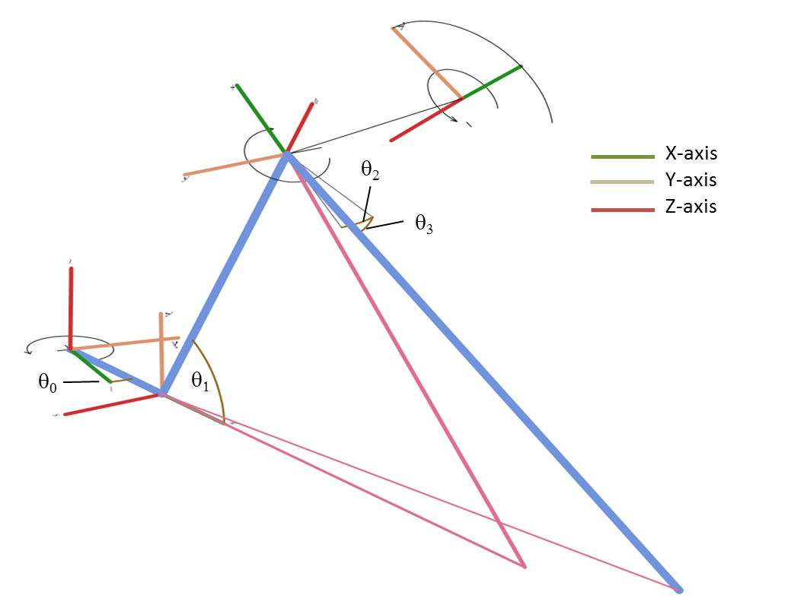

A Denavit Hardenberg transformation from anglei to anglei+1 is given via

1. rotation around the z-axis by joint angle $θ$
2. translation along the z-axis by *d*, and
3. translation along the x-axis by *a*
4. rotating around the x-axis by 

So, the Denavit Hardenberg parameters are:

|  |  |  |  |  |
| --- | --- | --- | --- | --- |
| Joint | a[°] | a[mm] | d[mm] | ❑ |
| hip | 90° | d0 | 0 |  |
| thigh | 90° | d1 | 0 |  |
| knee | *(90° +)*   | 0 | 0 |  |
| lower leg | 0 | d3 | 0 |  |

According to the coordinate system above,  has an offset of 90°. The general definition of a Denavit-Hardenberg (*DH*) transformation is

|  |  |
| --- | --- |
| $$T=\left(\begin{matrix}\cos{θ} & -\sin{θ} & \sin{θ}\sin{α} & a \cos{θ} \\ \sin{θ} & \cos{θ}\cos{α} & -\cos{θ}\sin{α} & a \sin{θ} \\ 0 & \sin{α} & \cos{α} & d \\ 0 & 0 & 0 & 1\end{matrix}\right)$$ | (6‑1) |

which is a homogeneous matrix with two rotations (x,z) and two translations (x,z).

Combined with the DH parameters, the following DH matrixes define the transformation from one joint to its successor:

|  |  |
| --- | --- |
| $$T_{0}^{1}=\left(\begin{matrix}\cos{θ_{0}} & 0 & \sin{θ_{0}} & d_{0 }\cos{θ_{0}} \\ \sin{θ_{0}} & 0 & -\cos{θ_{0}} & d_{0 }\sin{θ_{0}} \\ 0 & 1 & 0 & 0 \\ 0 & 0 & 0 & 1\end{matrix}\right)$$ | (6‑2) |
| $$T_{1}^{2}=\left(\begin{matrix}\cos{θ_{1}} & 0 & \sin{θ_{1}} & d_{1}\cos{θ_{1}} \\ \sin{θ_{1}} & 0 & -\cos{θ_{1}} & d_{1}\sin{θ_{1}} \\ 0 & 0 & 1 & 0 \\ 0 & 0 & 0 & 1\end{matrix}\right)$$ | (6‑3) |
|  |  |
| $$T_{2}^{3}=\left(\begin{matrix}1 & 0 & 0 & 0 \\ 0 & \cos{θ_{2}} & -sin{θ_{2}} & 0 \\ 0 & \sin{θ_{2}} & \cos{αθ_{2}} & 0 \\ 0 & 0 & 0 & 1\end{matrix}\right)$$ | (6‑4) |
|  |  |
| $$T_{4}^{3}=\left(\begin{matrix}\cos{θ_{3}} & -sin{θ_{3}} & 0 & d_{3}\cos{θ_{3}} \\ \sin{θ_{3}} & \cos{θ_{3}} & 0 & d_{3}\sin{θ_{3}} \\ 0 & 0 & 1 & 0 \\ 0 & 0 & 0 & 1\end{matrix}\right)$$ | (6‑6) |
|  |  |

Forward Kinematics

With the DH transformation matrixes at hand, computation of the leg’s pose out of the joint angles is straight forward. The matrix representing the gripper’s pose $T_{0}^{5}$ is

|  |  |
| --- | --- |
| $$T_{0}^{4}= T_{0}^{1} T_{1}^{2}{ T}_{2}^{3}T_{3}^{4}$$ | (6‑8) |

By multiplying the transformation matrix with the origin (as homogeneous vector), we get the absolute coordinates of the toe point (*TP*) centre point in world coordinate system (i.e. relative to the legs’s base).

|  |  |
| --- | --- |
| $$TP= \left(\begin{aligned}\begin{matrix}0 \\ 0 \\ 0\end{matrix} \\ 1\end{aligned}\right)T_{0}^{4}$$ | (6‑9) |

That was easy. The tricky part comes now.

Inverse Kinematics

Inverse kinematics denotes the computation of all joint angles out of the toe’s position (*TP*). Since the leg has four joints, it is becomes clear that there is an infinite number of solutions for that, so I need to predefine one angle with an arbitrary definition. Having the objective in mind of moving the higher limbs of the leg as little as possible, I arbitrarily chose ** and set it as angle bisector of the toe to the hip (from bird’s perspective):

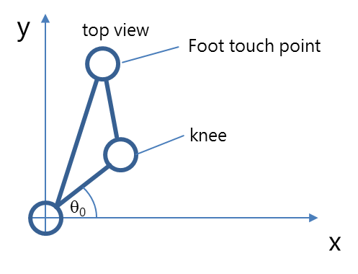

We get

$$θ_{0}=1/2atan2\left({FTP}_{x};{FTP}_{y}\right)$$

Later on, we will need the coordinates of end of the first limb (A) which is

$$A= \left(\begin{matrix}0 \\ 0 \\ \begin{matrix}0 \\ 1\end{matrix}\end{matrix}\right)T_{0}^{1}\left(θ_{0}\right)$$

Computation of the second angle ** at point A requires a geometric analysis. The leg is denoted in blue, all construction lines are red.

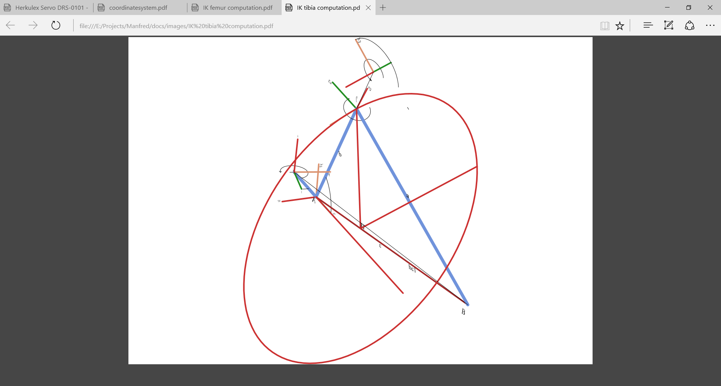We consider the triangle from A, B and C. The two lines $\overset{⃑}{AC}$ and $\overset{⃑}{CB}$ are of fixed length. So, the point C is upon the circle with the centre H and the radius of the triangle’s height. Additionally, C is defined as function of ** and **, so we should be able to derive ** by intersecting the circle with *C( ,)*.

The only thing we need to do is to express that in terms of coordinates. First, we compute the length of a, b and c:

$$a= \overset{⃑}{\left|BC\right|}=d_{2}$$

$$b= \overset{⃑}{\left|AC\right|}= d_{1}$$

$$c= \overset{⃑}{\left|AB\right|}$$

Now that the triangle is defined, we can compute the height $\overset{⃑}{h_{c}=\left|HC\right|}$ by Herons formula:

$$s= \frac{1}{2}\left(a+b+c\right) h_{c}= \overset{⃑}{\left|HC\right|}= \frac{2}{c}\sqrt{s\left(s-a\right)\left(s-b\right)}$$

The base of the height H is defined by

$$H= B+ \vec{BA}\frac{\sqrt{a^{2}-{\left(\overset{⃑}{\left|HB\right|}\right)}^{2}}}{\overset{⃑}{\left|AB\right|} }$$

Now we need to define the circle *K* with radius *h* and centre *H*. This is done by

$K=H+S\sin{a+T\cos{a}}$

with S orthogonal to $\vec{BH}$ beginning from *H* and T orthogonal to S and $\vec{BH}$:

$$\left|S\right|=\left|T\right|=h_{c} T=S×\overset{⃑}{BH}$$

So, with the arbitrary assumption $S_{z}=0$ and the length $\left|S\right|=h_{c}$

we get

$S\overset{⃑}{BH}=0\underset{⇒}{Sz=0}S= \left(\begin{matrix}±\sqrt{{h_{c}}^{2}- {\left(\frac{h_{c}}{\sqrt{{\left(\frac{{\overset{⃑}{BH}}_{x}}{{\overset{⃑}{BH}}_{y}}\right)}^{2}+1}}\right)}^{2}} \\ \frac{h_{c}}{\sqrt{{\left(\frac{{\overset{⃑}{BH}}_{x}}{{\overset{⃑}{BH}}_{y}}\right)}^{2}+1}} \\ 0\end{matrix}\right)$

(This equation could be simplified, but this way programming is easier by computing the y coordinate and deriving the x coordinate)

There are two possibilities for *S*, representing two configuration with knee up and knee down. We always take the healthy one where the knee is above the toe point. Finally, T is defined by its orthogonality to *S* and its length $\left|T\right|=h_{c}$:

$$T=\frac{h_{c}}{\left|T_{0}\right|}S×\overset{⃑}{BH}$$

Having the circle defined, we need to intersect it with the possible positions of C:

$$C=\left(\begin{matrix}0 \\ 0 \\ \begin{matrix}0 \\ 1\end{matrix}\end{matrix}\right)T_{0}^{1}T_{1}^{2}= \left(\begin{matrix}{{c_{0}d}_{1}c}_{1}+ {d_{0}c}_{0} \\ {{s_{0}d}_{1}c}_{1}+ {d_{0}s}_{0} \\ {d_{1}s}_{1}\end{matrix}\right)\begin{matrix}! \\ = \\ \end{matrix}H+S\sin{α+T\cos{α}}$$

Hereby denotes $s_{x}=\sin{θ_{x} }and s_{x}=\cos{θ_{x} }$. We consider only the equations of x and y coordinates and solve these for ${d_{1}c}_{1}$. Equating gives

$s_{0}\left(-{d_{0}c}_{0}+ H_{x}+S_{x}\sin{α+T_{x}\cos{α}}\right)= c_{0}\left(-{d_{0}s}_{0}+ H_{y}+S_{y}\sin{α+T_{y}\cos{α}}\right)$

This needs to be solved by in order to get point C. Unfortunately, we have sin and cos in the equation, but luckily with the same parameter. Wikipedia helps with sinusoids:

$$a\sin{α}+b\cos{α}=\sqrt{a^{2}+b^{2} }\sin\left(α+atan2⁡\left(b,a\right)\right)= \left\{\begin{matrix}\sqrt{a^{2}+b^{2} }\sin\left(α+\tan^{-1}{\frac{b}{a}}\right) & für a>0 \\ \sqrt{a^{2}+b^{2} \cos\left(α-\tan^{-1}{\frac{a}{b}}\right)} & für b>0 \\ a\sin{α} & für b=0\end{matrix}\right.$$

This is used to solve the equation above for 

a =

Out of  we get C by , out of C we compute * *by considering the z-coordinate of C:

$$C=\left(\begin{matrix}0 \\ 0 \\ \begin{matrix}0 \\ 1\end{matrix}\end{matrix}\right)T_{0}^{1}T_{1}^{2}= \left(\begin{matrix}… \\ … \\ {d_{1}s}_{1}\end{matrix}\right)$$

which results in

$$θ_{1}=\sin^{-1}\left(\frac{C_{z}}{d_{1}}\right)$$

The first angle is always the hardest, time for a beer.

We leave the knee-turn-angle *  *aside for a while and continue with the tibia **. This is done by considering the triangle ABC, and the angle at the point C represents **. In a fully elongated leg * * is 0.

Therefore, $θ_{3}= \cos^{-1}\left(\frac{b^{2}-a^{2}-c^{2}}{-ac}\right)$

The last angle * * is computed by use of

$$FTP= \left(\begin{aligned}\begin{matrix}0 \\ 0 \\ 0\end{matrix} \\ 1\end{aligned}\right)T_{0}^{4}$$

So, let’s have a closer look into the transformation matrix $T_{0}^{4}$ and check if there are some useful equations considering that we already have all other angles. Annoying multiplication results in

$$T_{0}^{4}=\left(\begin{matrix}. & . & . & c_{0}c_{1}d_{3}c_{3}+\left(s_{0}c_{2}+{c_{0}s}_{1}s_{2}\right)d_{3}s_{3}+\left({{c_{0}d}_{1}c}_{1}+{d_{0}c}_{0}\right) \\ . & . & . & {s_{0}c}_{1}d_{3}c_{3}+\left({-c}_{0}c_{2}+{s_{0}s}_{1}s_{2}\right)d_{3}s_{3}+{{s_{0}d}_{1}c}_{1}+{d_{0}s}_{0} \\ . & . & . & s_{1}d_{3}c_{3}-c_{1}s_{2}d_{3}s_{3}+{d_{1}s}_{1} \\ . & . & . & 1\end{matrix}\right)$$

Since we need to compare this to the toe point, it is not necessary to compute the full matrix, the right column is sufficient. We are lucky, the third line has only one expression that depends on * *, so we get

$${θ_{2}= sin}^{-1}\left(\frac{{FTP}_{z}-{d_{1}s}_{1}-s_{1}d_{3}c_{3}}{-c_{1}d_{3}s_{3}}\right)$$

Again, *arcsin* results in two solutions, so we need the other coordinates as well to check which solution is valid.

That’s it. Surprisingly complex for a leg with only 4 degrees of freedom.

This is implemented in [LegKinematics.cpp](https://github.com/jochenalt/Pentapod/blob/master/code/Kinematics/src/LegKinematics.h).

Body Kinematics

Attaching 5 legs to a body means to compute the leg kinematics depending on each hip. Additionally, we might want to translate and rotate the belly in certain limit. Since the chapter on leg kinematics computes the angles out of the toe in the hip coordinate system, we need to translate each leg’s toe point into the hip’s coordinate system.

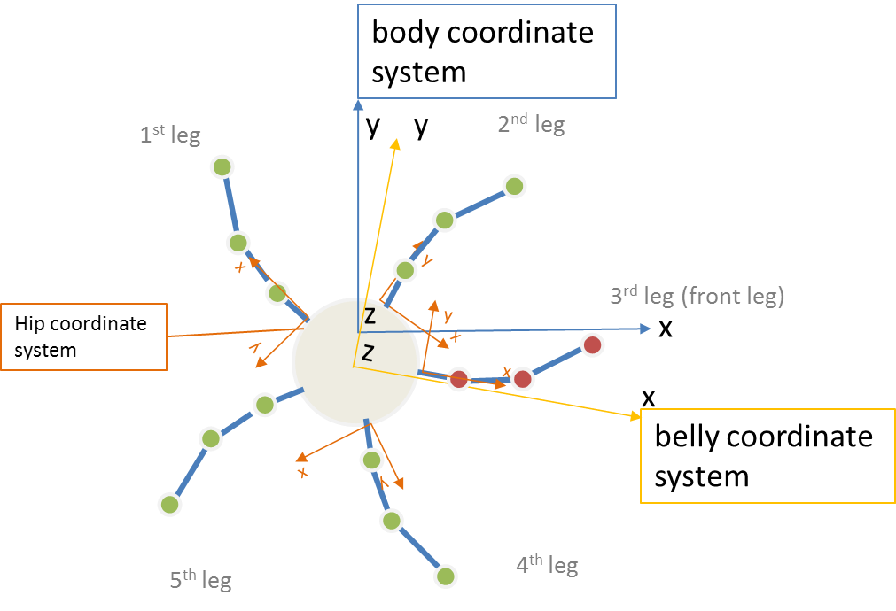The pentapod’s pose is given in the body’s coordinate system, which origin is on the ground right below the body button. Since the belly can translate or rotate, the next coordinate system is the belly coordinate system which origin is the belly button. When the pentapod is in the default position, the belly coordinate system is translated in the z-axis only by the height of the belly. Finally, we have 5 hip coordinate systems which are x-translated by the distance of the belly to the hip and z-rotated by $\left(n-3\right)\frac{2π}{5}$, where *n* is the number of the leg.

We define the transformation matrix *Belly* that defines the belly coordinate system out of the body coordinate system, that is a 3D rotation matrix plus a translation along the belly coordinates:

$$Belly=\left(\begin{matrix}\cos{z}\cos{y} & -\sin{z cosx+\cos{z\sin{y\sin{x}}}} & \sin{z\sin{x+\cos{z\sin{y\cos{x}}}}} & {belly}_{x} \\ \sin{z\cos{y}} & \cos{z\cos{x+\sin{z\sin{y\sin{x}}}}} & -\cos{z }\sin{x+\sin{z\sin{y\cos{x}}}} & {belly}_{y} \\ -siny & \cos{y\sin{x }} & \cos{y\cos{x }} & {belly}_{z} \\ 0 & 0 & 0 & 1\end{matrix}\right)$$

Per leg we have an own transformation matrix which is a rotation in the xy-pane around z

${Leg}_{n}=\left(\begin{matrix}\cos{ϑ} & -\sin{ϑ} & 0 & d_{hip} \\ \sin{ϑ} & \cos{ϑ} & 0 & 0 \\ 0 & 0 & 0 & 0 \\ 0 & 0 & 0 & 1\end{matrix}\right)$ where $ϑ= \left(n-3\right)\frac{2π}{5}$,

Having a point in one coordinate system and watching it from another one is done by multiplying it with the inverse transformation matrix. So, the toe point from the hips coordinate system *toehip* is computed out of the toe point from the body’s coordinate system by

$${toe}_{hip}= {\left({Leg}_{n}Belly\right)}^{T} {toe}_{body}$$

Computing-wise, the inverse matrix is done by Gauss or similar approaches with a complexity of $o(\frac{nm}{2})$, which might be bad for the performance. Luckily, the inverse of a symmetric rotation matrix is the transposed matrix, and the rest can be computed by

$${\left(\begin{matrix}R & T \\ 0 & 1\end{matrix}\right)}^{-1}= \left(\begin{matrix}R^{T} & -R^{T}T \\ 0 & 1\end{matrix}\right)$$

which is much simpler.

All this is implemented in [BodyKinematics.cpp](https://github.com/jochenalt/Pentapod/blob/master/code/Kinematics/src/BodyKinematics.h).